**Lab 05 Tasks (DNS, FTP and SMTP)**

**Task 01:** Implement the given topology. Add some web servers in your network. Implement **DNS** & add

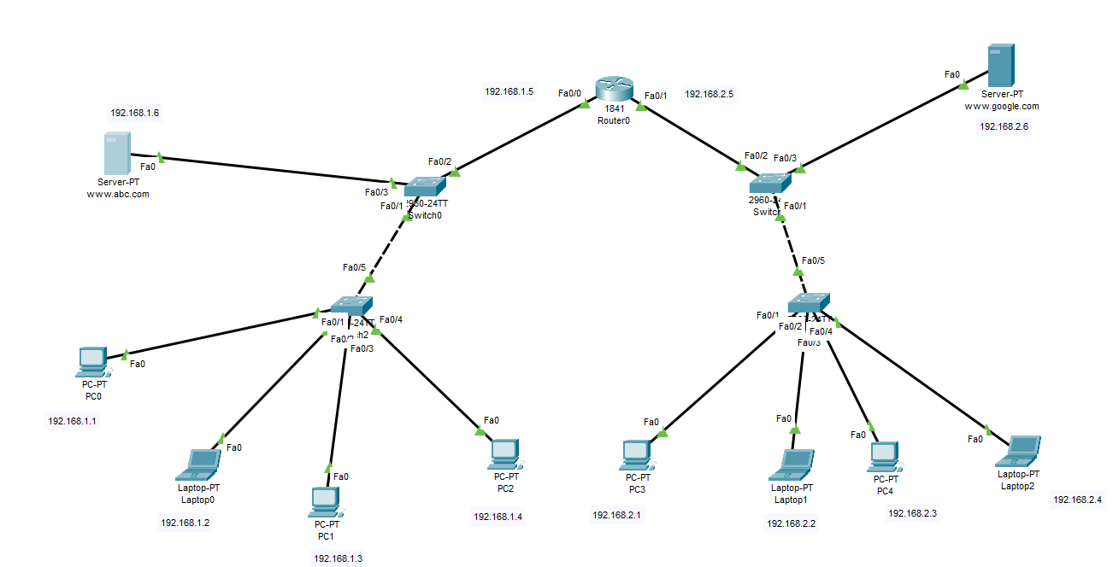records of your web servers.

**Task 02:** Let’s suppose your organization need to create it’s on small server (for provide some services) based network.

With below mentioned topology and instructions:

a) Configure **SMTP** (create account with your last name along with last 3 digits roll number) send mail from PC-A to PC-B.

b) Configure **FTP** server create account with your first name, password with your roll number and filename with your last name (.bin extension) show all connection results.

